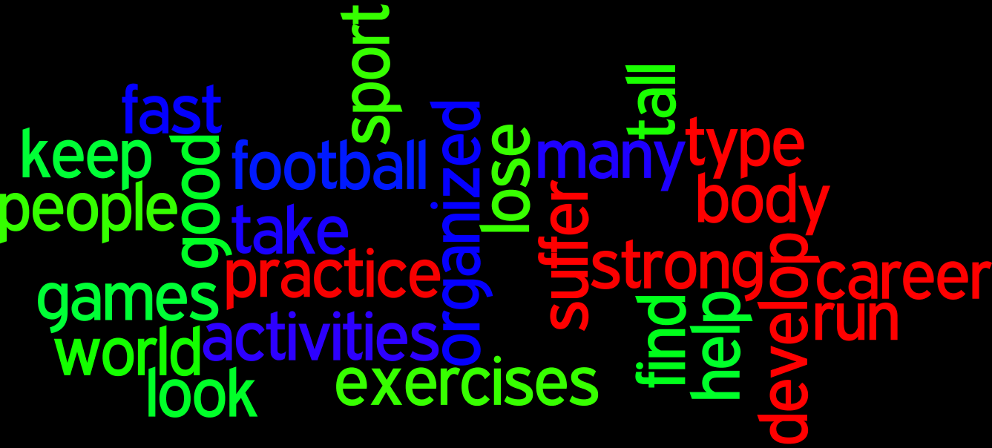

Ex.1 Find the suitable words and put down them in the text.

Sports

is probably as old as the humanity itself. It has been developing with the developing and growth of the mankind. All over the people of different ages are very fond of sports and games.

Sport not only helps people to become and to develop physically but also makes them more and better disciplined in their daily . It makes for a healthy mind in a healthy body. Sports help people to in good health.

We all need to exercise. Even if you don’t plan to make a in sport you still have to practice. Regular gives you more energy. That is why many people who from general tiredness should take more exercise than more rest. Exercise makes you fell and look better.

Ex. 2 Make two sentences using these words.

